OCR USING ARTIFICIAL NEURAL NETWORK

Sanjeev Ranganathan
VIT University, Vellore
14BCE0153

Abstract— Optical Character Recognition (OCR) is the conversion of images of typed, handwritten or printed text into machine-encoded text. In this project we are going to make an OCR using Artificial Neural Network. An artificial neural network is inspired by biological neural network which are used to estimate or approximate functions that can depend on a large number of inputs that are generally unknown. We will be using neural network with input as an image converted into black and white using threshold filter, with softmax error detection method, backpropagation method and gradient decent for supervised training of neural network.
Introduction
OCR is transformation of any image which is printed, handwritten or typed in text format into machine-encoded text. Optical code reader commonly used as a type of information entry that we get from printed paper data records, which can be passport documents, invoices, bank statements, computer generated receipts, business cards, mail, prints of static-data, or any kind of suitable documentation. It is a most commonly used method of digitizing printed texts so that they can be electronically edited, stored, searched more precisely, displayed line by line, and used in machine processes like cognitive computing, machine translation, text-to-speech, key data and text mining.

Artificial Neural Network a computing system made up of a number of simple, highly interconnected processing elements, which process information by their dynamic state response to external inputs. Neural networks have been used to solve a wide variety of tasks, like computer vision and speech recognition, that are hard to solve using ordinary rule-based programming.

Image Processing

Image Enhancement
Before inputting the image of the digit we perform some image preprocessing. In image enhancement we perform thresholding and binarization using the basic formula.

Morphological Image processing
After image enhancement we proceed with morphological image processing for feature extraction for convoluted neural networks. We use hit and fit method to extract information from the image and fed into the neural network.

Methodology
An Artificial Neural Network is used to classify the given image. Neural network is mostly made of three type of layers of nodes input node layer, hidden node layer and output node layer and an additional bias node. In Neural Network, each node perform some simple computation and each connection conveys a signal from one node to another through neurons labeled by a number called connection strength or weight of neurons.

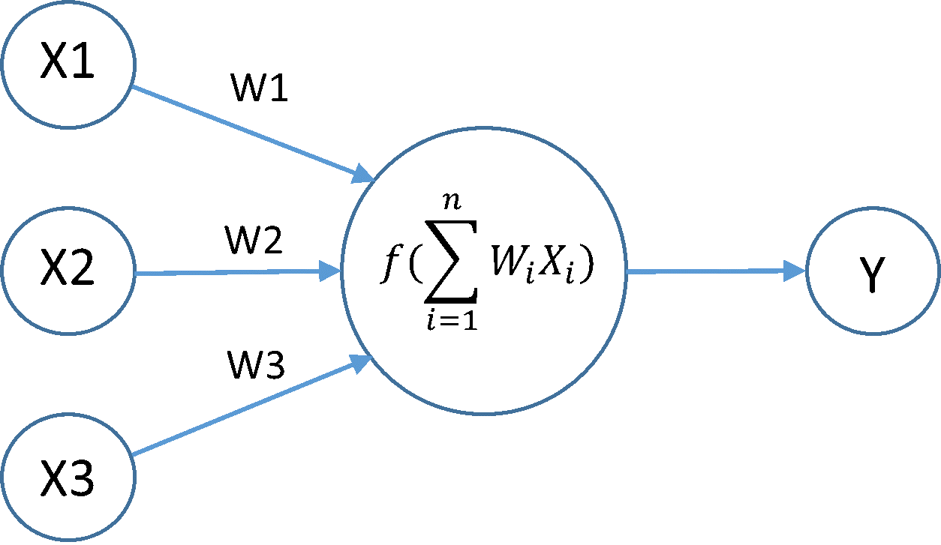

Hyperbolic tangent function is used as activation function.

The softmax function is used for error detection.
Sotmax p(i) is given by
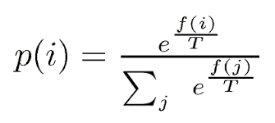

Bock Diagram of Image processing-
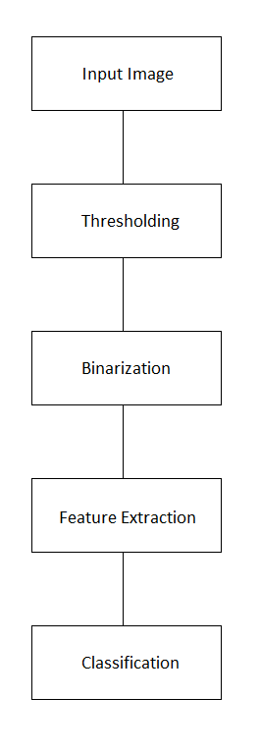
Neural Network
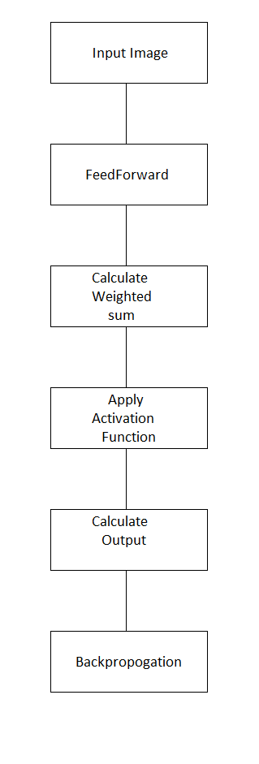

Output Of Threasholding And Binarization



Output Of Feature Extraction



Architecture of Neural Network

Input Node 4 × 28 × 28
Hidden Node 4 × 4
Output Node 10 × 1

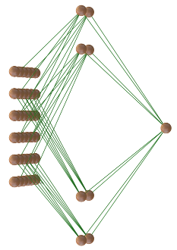

Result
A set of 2115 untrained images are used to test neural network. The neural network shows an accuracy of 90% in which 1917 cases were recognized correctly.

The figure shows the loss during the training of neural network.

The graph given below shows the loss during training of a single image over 200 epochs.

Conclusion
The experimental results illustrates that the Artificial Neural Network can be applied successfully to solve the Optical Character Recognition problem with hand written digits.
The system can be enhanced for the recognition of all 10 digits. However, other kinds of pre-processing and neural network models may be tested for a better recognition rate in the future. The test set used in this experiment is of at least five different types of fonts. This can be tested for a greater number of fonts. Better feature extraction techniques must be used for better performance.

References

- Sonali. B. Maind, Research paper on Basics of neural network.
- V.Kalaichelvi, Ahammed Shamir Ali, Application of Neural Networks in Character Recognition
- Gaurav Kumar, Pradeep Kumar Bhatia Neural Network based Approach for Recognition of Text Images
- Sameeksha Barve, Optical character recognition using Artificial neural network.
- Ankit Sharma, Dipti R Chaudhary, Character recognition using Artificial neural network
- Siddhi Sharma, Neetu Singh, Optical character recognition using Artificial neural network approach
- Chirag Patel, Ripal Patel, Palak Patel, Handwritten Character recognition using neural network.

